ProjectName
Deployment Guide

Revision History
Author | Revision Number | Date
TCSCODER | 1.0

Deployment Instructions 3
1. Organization of Submission 3
2. Application Setup 3
3. Database Setup 3
4. IIS Deployment Instructions 3
5. Visual Studio Deployment Instructions 7
7. Web API Verification 9
8. Resource Contact List 14

Deployment Instructions

Organization of Submission
  - Directory Structure
Directory / File Name | Description
Database | Contains all required scripts to setup the database.
Docs | Contains the deployment guide, and Postman exported collection.
Src | The source code.

Application Setup
Preconditions:
- Windows OS with .NET Framework 4.5+ (Required)
- Microsoft SQL Server 2012+ is installed. (Required)
- Microsoft IIS 8.5 (Optional, can also run in IIS Express)
- Visual Studio 2015 is installed. (Required to build solution and run tests. For deployment in IIS – optional.)

Database Setup
Install the scripts under Database directory.
- Create database

- Execute the below scripts one by one:

- DDL.sql
- [optionally] TestData.sql – required to verify Web API with Postman.

IIS Deployment Instructions

If you don’t want to use IIS yet, you can use Visual Studio to run it directly. Please refer to section 6.

  - Extract the package.

  - Setup the database. Refer to section #3.

  - Deploy the \src\WWF directory to IIS with “DefaultAppPool” application pool.
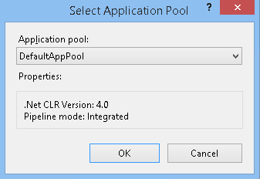
  - Configure the Web.config under \src\WWF\ directory. Make it fits your environment. Please make sure you configure External Login Provider, most of other properties have default configuration values and should work without any modifications.

Node name | Description
<connectionStrings> | Connection strings to database.
<appSettings> | Contains External Login Providers configuration.
<unity > | Contains all configuration values that will be injected to services.
<log4net> | Log4net configuration.

BasePersistenceService configuration properties:

Property | Description | Required
Logger | The log4net ILog instance. | Yes
ConnectionString | The persistence connection string. | Yes

LookupService configuration properties:

Property | Description | Required
all properties from the BasePersistenceService class

UserService configuration properties:

Property | Description | Required
all properties from the BasePersistenceService class
PasswordResetEmailSubject | The subject for password reset notification email. | Yes
PasswordResetEmailBodyTemplate | The body template for password reset notification email. | Yes
TokenExpiration | the token expiration time in minutes. | Yes

EmailService configuration properties:

Property | Description | Required
Logger | The log4net ILog instance. | Yes
SmtpClient | The SmtpClient used for sending emails. | Yes
FromAddress | The 'From' email address used for sending email notifications. | Yes

LookupController configuration properties:

Property | Description | Required
LookupService | The Lookup service. | Yes

UserController configuration properties:

Property | Description | Required
UserService | The User service to manage users and security operations. | Yes

AuthorizationFilter configuration properties:

Property | Description | Required
Logger | The log4net ILog instance. | Yes
UserService | The User service. | Yes

ExceptionFilter configuration properties:

Property | Description | Required
Logger | The log4net ILog instance. | Yes

LoggingActionFilter configuration properties:

Property | Description | Required
Logger | The log4net ILog instance. | Yes

Sample external login providers configuration. In case you want to use these values, make sure you host your backend WEB API on http://localhost:50630/:
<appSettings>
<add key="GoogleClientId" value="307492493635-03007v505jia4rkbtchi90in0j6668ap.apps.googleusercontent.com" />
<add key="GoogleClientSecret" value="huirCOj2OVcRcErZyX5LNDoF" />
<add key="FacebookAppId" value="742961712522135" />
<add key="FacebookAppSecret" value="195dca355731b31a03287ecc01a9812b" />
<add key="TwitterConsumerKey" value="hWhJTFiMiLxmAcLde6nrNWRzs" />
<add key="TwitterConsumerSecret" value="VYBbshaRPF3lBmDSV86HTrdHUHv25toVGVatPIG1I3Gcu5gSFd" />
</appSettings>

Sample log4net configuration:
<log4net>
<appender name="FileAppender" type="log4net.Appender.FileAppender">
<file value="weblog.txt" />
<appendToFile value="true" />
<layout type="log4net.Layout.PatternLayout">
<conversionPattern value="%date [%thread] %-5level %logger - %message%newline" />
</layout>
</appender>
<logger name="default">
<level value="DEBUG" />
<appender-ref ref="FileAppender" />
</logger>
</log4net>

Sample Smpt configuration:
<system.net>
<mailSettings>
<smtp deliveryMethod="SpecifiedPickupDirectory">
<specifiedPickupDirectory pickupDirectoryLocation="d:\tc2016\temp\emails\"/>
</smtp>
</mailSettings>
</system.net>

Sample Unity configuration:
<unity>
{type aliases removed for clarity}
<containers>
<container>
<register type="IEmailService" mapTo="EmailService">
<property name="Logger" />
<property name="SmtpClient" />
<property name="FromAddress" value="your_address@gmail.com" />
<method name="CheckConfiguration" />
<lifetime type="singleton" />
</register>
<register type="ILookupService" mapTo="LookupService">
<property name="ConnectionString" value="DefaultConnectionString" />
<property name="Logger" />
<method name="CheckConfiguration" />
<lifetime type="singleton" />
</register>
<register type="IUserService" mapTo="UserService">
<property name="PasswordResetEmailSubject" value="Password reset link." />
<property name="PasswordResetEmailBodyTemplate" value="Hi %FirstName%, here is a link to reset your password." />
<property name="TokenExpiration" value="60" />
<property name="ConnectionString" value="DefaultConnectionString" />
<property name="Logger" />
<method name="CheckConfiguration" />
<lifetime type="singleton" />
</register>
<register type="AuthorizationFilter">
<property name="Logger" />
<property name="UserService" />
<method name="CheckConfiguration" />
<lifetime type="singleton" />
</register>
<register type="ExceptionFilter">
<property name="Logger" />
<method name="CheckConfiguration" />
<lifetime type="singleton" />
</register>
<register type="LoggingActionFilter">
<property name="Logger" />
<method name="CheckConfiguration" />
<lifetime type="singleton" />
</register>
<register type="LookupController">
<property name="LookupService" />
<method name="CheckConfiguration" />
</register>
<register type="UserController">
<property name="UserService" />
<method name="CheckConfiguration" />
</register>
</container>
</containers>

Visual Studio Deployment Instructions
This deployment can provide the quick environment for development.

  - Extract the package.

  - Setup the database. Refer to section #3.

  - Setup Active Directory Domain Services. Refer to section 4.
  - Open the file \src\WWF.Backend.sln in Visual Studio.

  - Configure the Web.config (refer section 4.4) in project WWF Make it fits your environment.

  - Set WWF as startup project.

  - Click menu Debug -> Start Without Debugging (or Press Ctrl + F5) to host Web API.

- Verification

  - Follow section #5 to set up deployment.

- Configure the App.config in project WWF.Tests. Make it fits your environment. Refer section 4.4 for more details. Please note that App.config doesn’t require configuration for Controllers and Action Filters.
You also need to update path to email folders App.config file:
<appSettings>
<add key="EmailFolder" value="d:\tc2016\temp\emails\"/>
</appSettings>

  - Please note that default unit tests connection string points to the same databas. This means that test data will be cleared in this DB. If you want to keep your test data, change the connection string to point to other test DB.
Click menu Test -> Run -> All Tests
As a result you should see all tests passed:
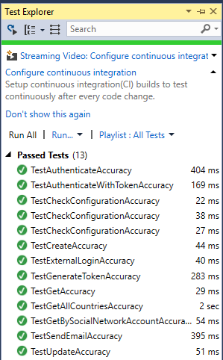

Web API Verification
- Import the test data: \Database\TestData.sql to database.
- Host application in either IIS or by using VS 2015 as described in previous sections.
- Open PostMan Chrome App
- Import collection from \docs\WWF.json.postman_collection by pressing highlighted button:
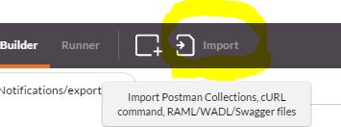

All predefined queries should be loaded:
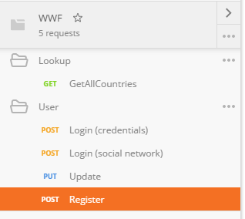

- Import environment variables from \docs\WWF.postman_environment
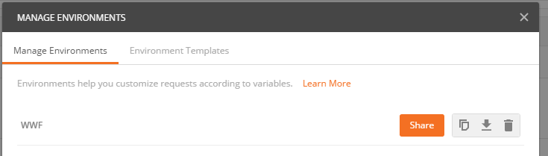
  - Lookup.GetAllCountries
Expected:
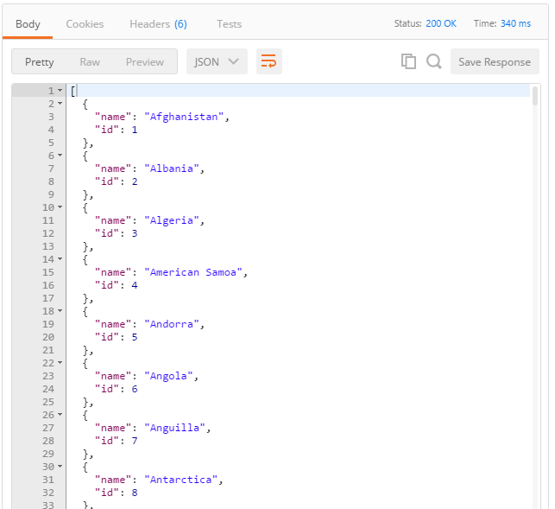
Note: In some cases you might need to re-import test data, otherwise request may not work.

Resource Contact List

Name | Resource Email

